**Name**: Dentate Gyrus Granule (DGg) (Staley et al., 1992)

**Biological Data**

**Passive properties**: Vrest = -84 ± 1.0 mV Tau =26.9 ± 1.2 ms Rin = 228 ± 14.2 MΩ (Staley et al., 1992)

________________________________________________________________________________________

**Passive properties of model OLM Interneuron:**

|  |
| --- |
| **1. V_rest = -84.0 mV**  **2. Calculation of time constant:**  Start inject: 300ms / -84.0mV Final Value: ~ -107.602 mV Difference: -23.602 | 63.2% = -14.916 | -84.0 - 14.916 = -89.916 Time at -89.916: 322.7ms τ = 322.7-300  τ = 22.7 ms  **τ = .0227 s**  **3. Input Resistance**  ΔV/ΔI = ( -84.0 – (-107.602) )/( 0 – (-100) )  = 23.602mV / 100pA  **R_in = 236.01 MΩ** |

**Comparison of F-I curves (Actual: Green, Model: Black)**:

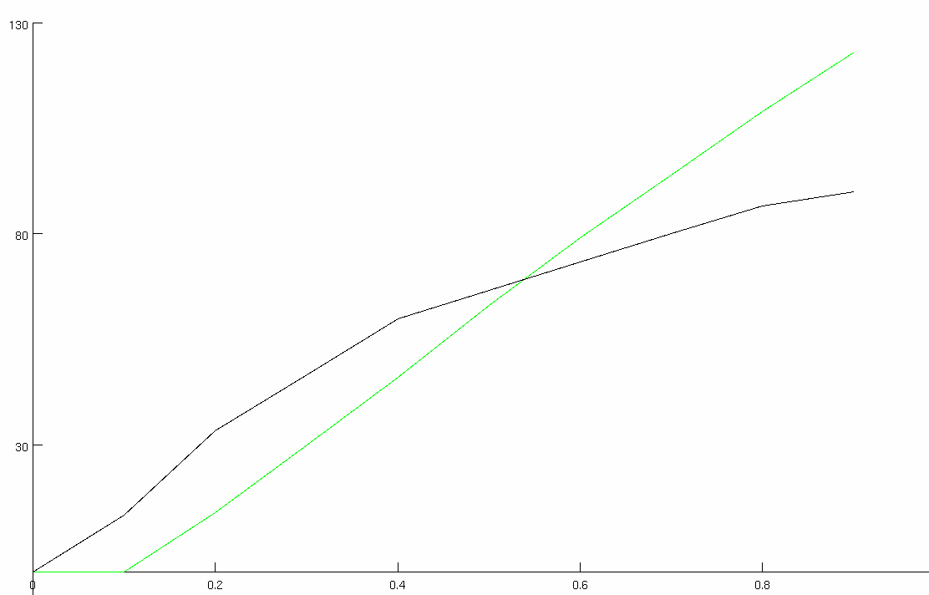

**Match with reported current injection responses (provide all):**

|  |  |  |
| --- | --- | --- |
| **200** |  |  |
| **pA** | **Real** | **Cell Model** |

**Table 2-1. GATING PARAMETERS OF ION CHANNELS**

|  |  |  |  |  |  |
| --- | --- | --- | --- | --- | --- |
| **Current Type** | **Gating Variable** | **α** | **β** | $$x_{∞}$$ | **τx (ms)** |
| *INa* | *p=3* | $$\frac{-0.4(V+30)}{exp[-(V+30)/7.2]-1 }$$ | $$\frac{0.124(V+30)}{exp[(V+30)/7.2]-1 }$$ | $$\frac{1}{\exp\left[(-V-35.5)/7.2\right]+1}$$ | $$\frac{0.6156}{α+β}$$ |
| *q=1* | $$\frac{-0.03(V+45)}{exp[-(V+45)/1.5]-1 }$$ | $$\frac{0.01(V+45)}{exp[(V+45)/1.5]-1 }$$ | $$\frac{1}{\exp\left[(V+40)/4\right]+1}$$ | $$\frac{0.6156}{α+β}$$ |
| *IKdr* | *p=1* | $$exp[-0.1247(V-0)]$$ | $$exp[-0.0873(V-0)]$$ | $$\frac{1}{\exp\left[(0-V)/11\right]+1}$$ | $$\frac{12.5*β}{1+α}$$ |
| *IKM* | *p=2* | $$\frac{0.016}{exp[-(V+52.7)/23] }$$ | $$\frac{0.016}{exp[(V+52.7)/18.8] }$$ | $$\frac{1}{\exp\left[(-V-35)/10.34\right]+1}$$ | $$\frac{7}{α+β}$$ |
| *INap* | *p=1* | ― | ― |  |  |

**Table S2. Parameters of single cell models**

|  |  |  |
| --- | --- | --- |
|  | OLM interneuron | |
|  | soma | dendrites (2) |
| Cm (µF/cm2) | 0.8 | 0.8 |
| Ra (Ωcm) | 35.4 | 35.4 |
| Conductance (mho/cm2)  gNabar  gKdrbar  gLeak  gNapbar  gImbar | 0.08  0.02  3.5e-5  0.0005  0.0009 | 0.08  0.02  3.5e-5  0.0005  0.0009 |

**References**

Staley KJ, Otis TS, Mody I. 1992. Membrane properties of dentate gyrus granule cells: Comparison of sharp microelectrode and whole-cell recordings. J Neurophysiol 67:1346–1358.